Exporting a Windows Instance using VMWare Standalone Converter
If the Instance is Windows and it has additional virtual drives, you may download and install VMware Standalone Converter onto the Instance and convert and store the VM onto the Instance’s additional virtual drive. If you have a Linux instance, there is no way to convert it. You will need to create an Archive of it and export the Archive. See the document, Exporting Linux Archives in our Support area.
The conversion process is quite fast (about 20-50 minutes to convert and store on the Instance and can thus be pushed using IBM Aspera or Box.com very quickly), does not require the Migration Sandbox Instance, but only works with Windows Instances.
This method requires you to have/create a VMware user account to download the free VMware Converter Standalone 6.1.x tool.
This process creates and stores a VMWare-formatted VM on the Running Instance itself, typically on the existing 2nd drive.
Disclaimer: Please not that if you run into a restart issue, you may need to remove the Xen drivers before starting. See pages 8-9 for those instructions.

Important Notes Before You Begin
Note: The use of VMWare Converter is not supported by ASKIBM Support. However, please see the end of this document for suggestions if you cannot use the VM on your laptop.
Note: As of July 2017, we have found that exported Windows2016 systems will not run on VMWare Workstation 12.x or VMWare Player. There is no known fix for this and VMWare will need to fix the issue.
Note: Ensure your Instance’s secondary drive contains enough free space to hold the export. For example, if the system contains a 100GB C drive and a 200GB D drive, and C has 90GB used and D has 150GB used, then the “system” is 240GB large. Since D only has 50GB free, the converted system will not fit. You will need to either free up more space or add an additional drive (contact Cloud Concierge email support at askibmst@ca.ibm.com and state how large the additional drive should be). Example calculation below:

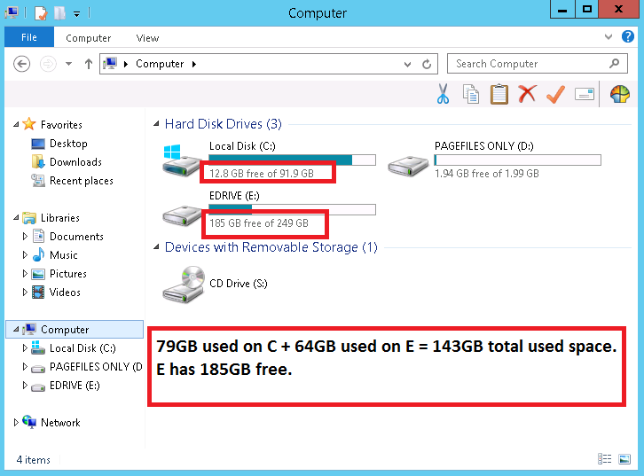

If the ASKIBM team states that we cannot add a 3rd hard drive to your system, you will need to Archive the running Windows Instance and then follow the Box documentation (https://ibm.box.com/s/yzif8pgy5a7dxqs58gjfes5gcgkvv7e2) regarding how to export an Archive.

Before you start:
- Ensure your Instance is Windows
- Free up drive space and empty Recycle Bin
- Stop programs (database, web server, etc.) so the conversion tool runs as fast as possible
- If you have a large database, you may wish to compress it with 7zip or Winrar to save drive space
- Ensure your Instance is on the public internet
- Request the public network adapter speed be increased to 100Mbit via askibmst@ca.ibm.com

Step 1: RDP into your Windows Instance

Step 2: Download and install VMware vCenter Standalone Converter 6.x from
https://my.vmware.com/web/vmware/info/slug/infrastructure_operations_management/vmware_vcenter_converter_standalone/6_1

Step 3: Open VMware vCenter Standalone Converter 6.x

Step 4: Click the Convert Machine button
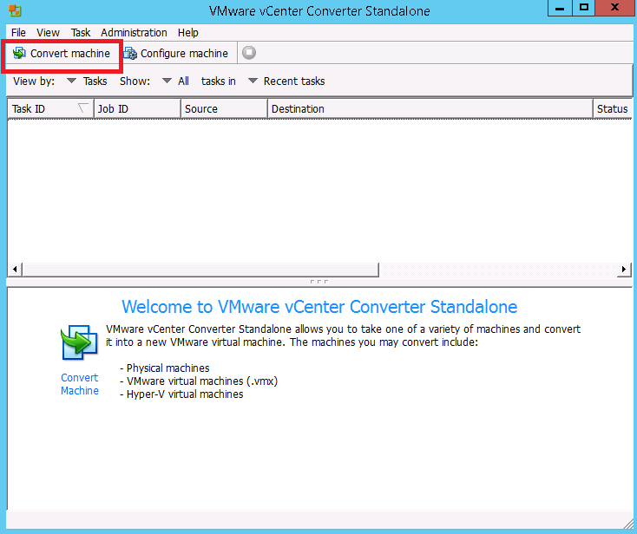
Step 5: Choose the Powered On bubble

Step 6: Choose This Local Machine in the pull-down menu
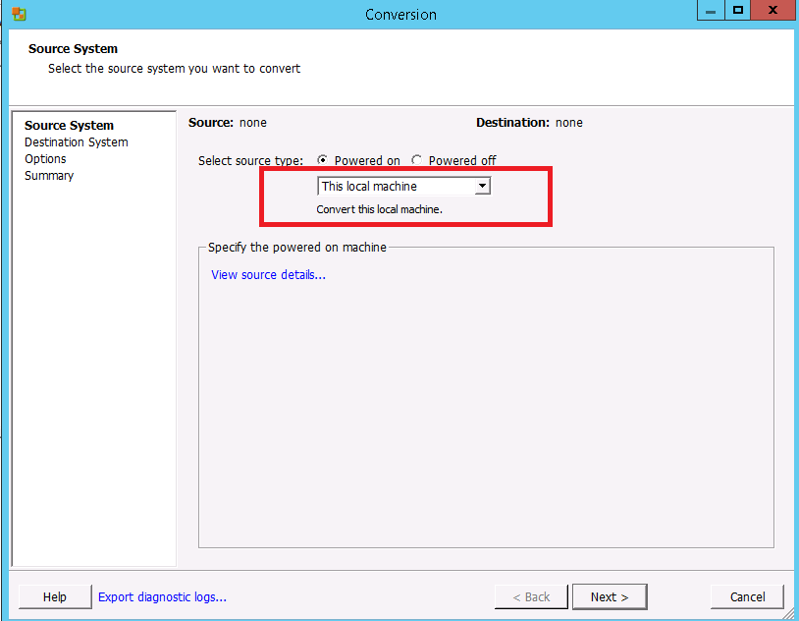
Step 7: Click View Source Details to understand how much free disk space you will need on your Instance to create and save the VM. In the below screenshot the VM would be about 195GB.
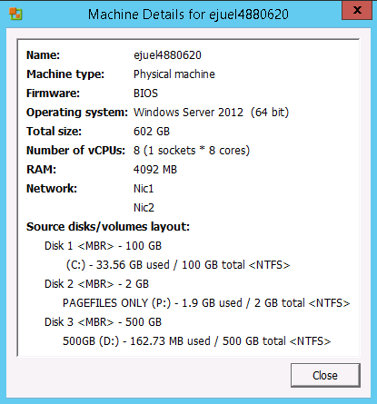
Step 8: Click Close

Step 9: Click Next

Step 10: Set the Destination Type to VMware Workstation or other VMware VM

Step 11: Set the VMware Product to VMware Workstation 10.x

Step 12: Set the Location to a virtual drive on your Instance that enough free space such as d:\temp. It does not have to be stored to a brand new, unused drive.
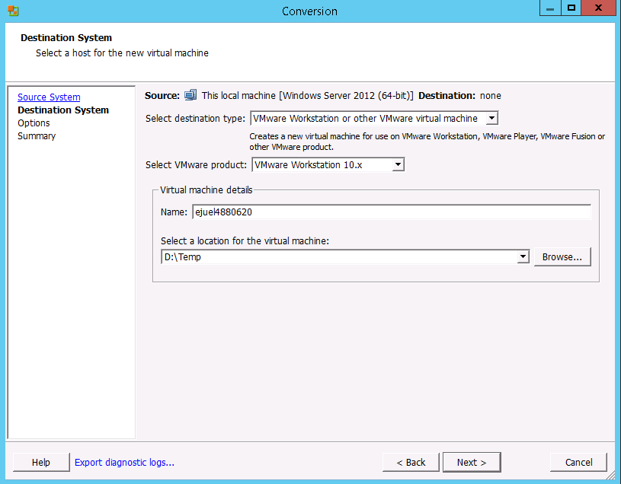
Step 13: Click Next

Step 14: In the Data To Copy area, deselect the 2GB swap partition
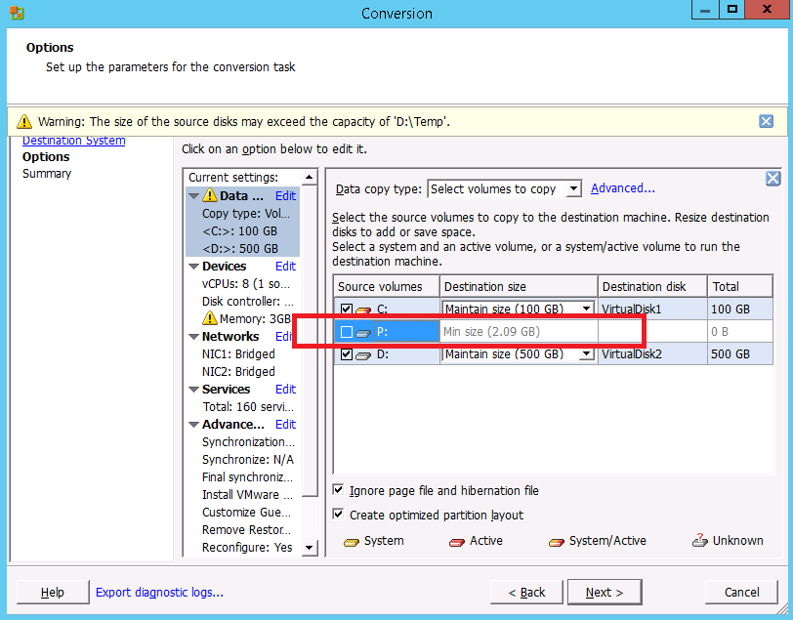
Step 15: Click Networks and change Network Adapters to Connect to “1”, and set Connection Type to “NAT”
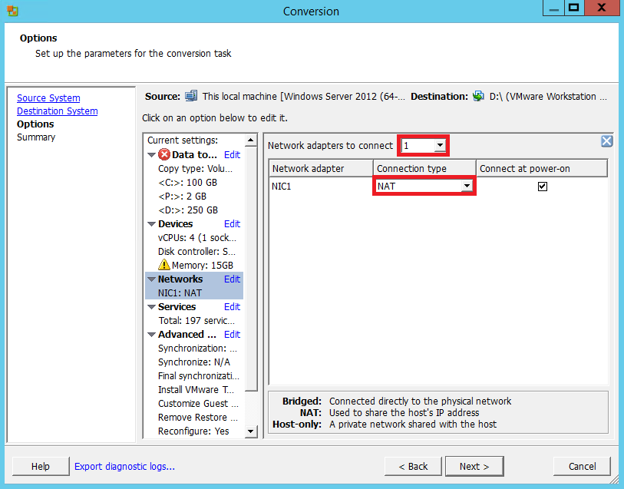
Step 16: Click Next

Step 17: Click Finish
The process takes between 30 and 90 minutes depending on how much drive space is currently used on your Instance. Once completed, you can use IBM Aspera, Box.com, or FTP client to push your VM off your Instance. Aspera and Box.com are highly recommended. You may also want to compress your VM with 7Zip or Winrar which will typically compress more than 50%.
Although the use of VMWare Converter is not supported by ASKIBM Support, a few suggestions for problems using the VM on your laptop are:
- Ensure you are using VMWare Workstation 10.x or newer
- Boot the VM into Windows Safe Mode and uninstall Xentools and reboot
- Ensure the VM is properly configured for your machine’s hardware (especially CPU and cores)
- Ensure your BIOS is set properly to run VMs
Some users obtain the following error message when trying to export the Windows 2012 from SoftLayer to a local computer:

- “Your PC ran into a problem and needs to restart… SYSTEM_THREAD_EXCEPTION_NOT_HANDLED”

To workaround this issue, please follow the instructions listed prior to the archive process:

Step 1: Uninstall all Citric and Xen software

Step 2: In Device Manager, select “show hidden devices” and remove all Xen or Citrix devices.

Note: Look for disk drives, storage devices, network and system bus devices and then reboot.
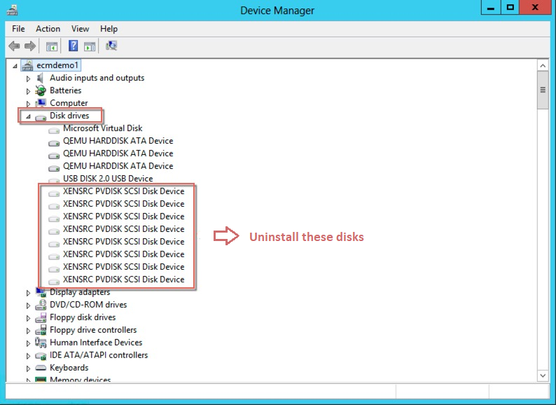
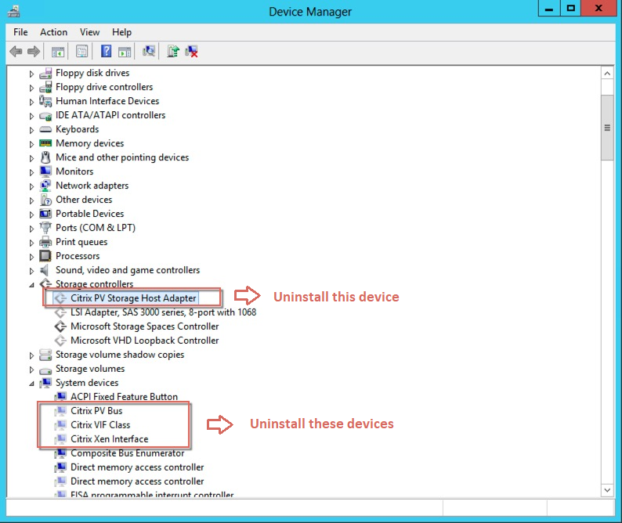
Step 3: In Safe Mode, delete all xen*.* files from all subdirectories of Windows\system32\
Note: Subdirectories include system32, system32\drivers, system32\driverstore\filerepository

Step 4: Convert your computer

Step 5: If the error message shows up during the botting of your laptop, go back and delete the Xen*.* files again using the recovery mode command line.

Note: In recovery mode, it is a little bit trick to find which drive is your real C drive as the letter will
change, but it will not be the X: drive since that is the rescue partition.

You will also need the administrator password to login to recovery mode which is found on your ‘MyCloud’ page. If it is not easily visible, the administrator password is also the same as the SoftLayer console password.

